Assignment – C
- Find students with marks greater than 80.
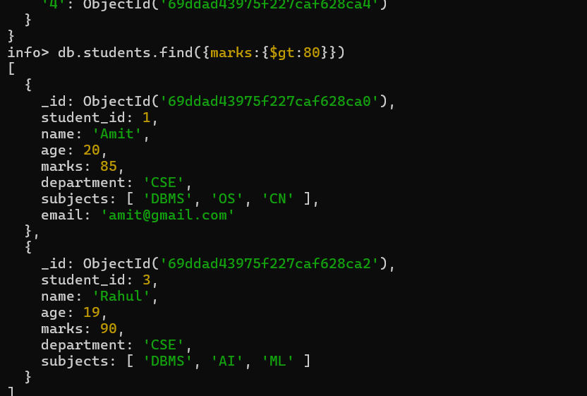
- Find students aged less than or equal to 20.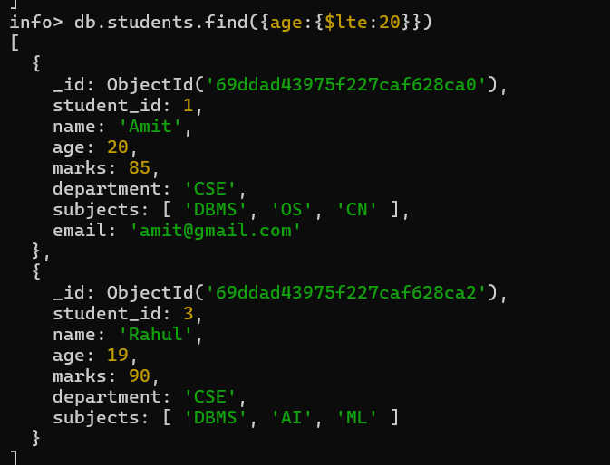

- Find students with marks between 70 and 85.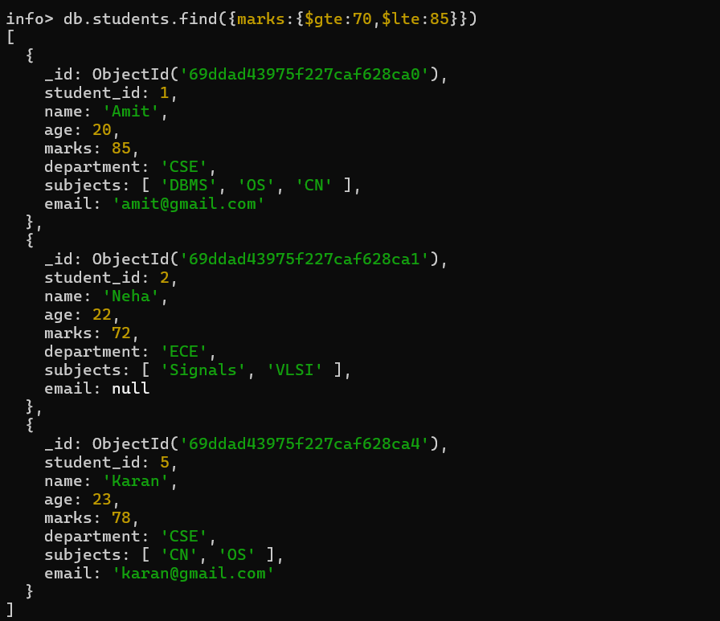
- Find students not belonging to CSE department.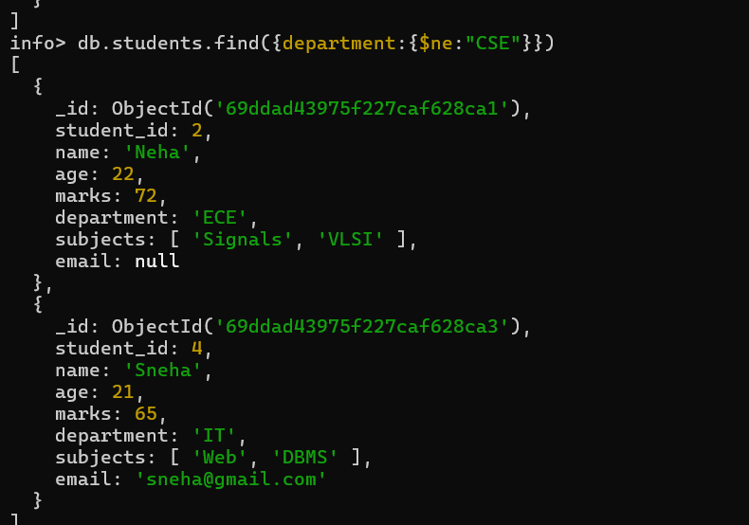
- Find students whose age is exactly 21.
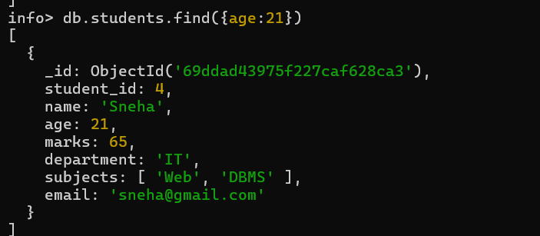
- Find students with marks less than 75.
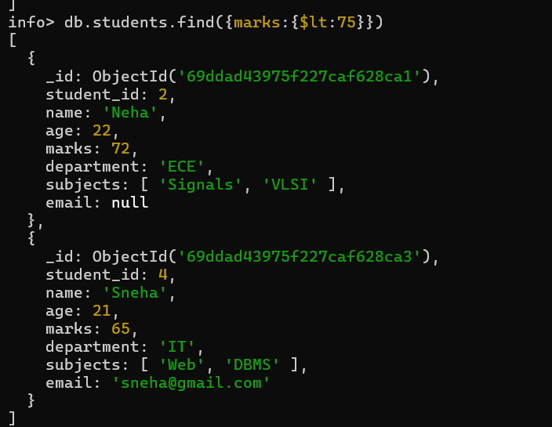

- Find students whose department is either CSE or IT.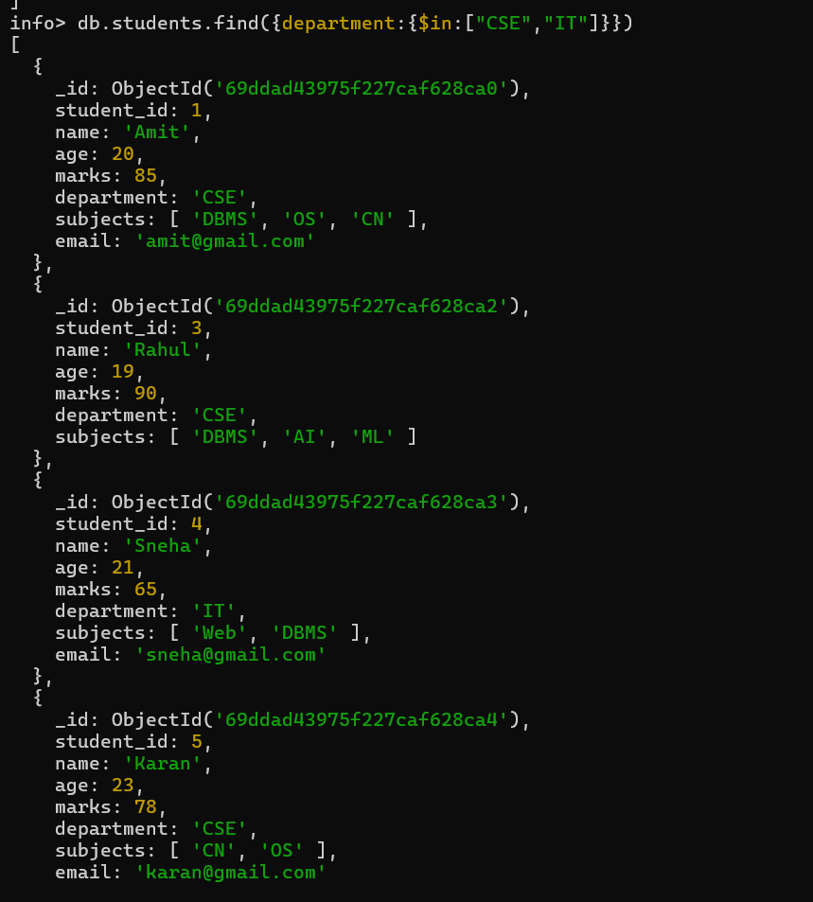
- Find CSE students with marks above 80.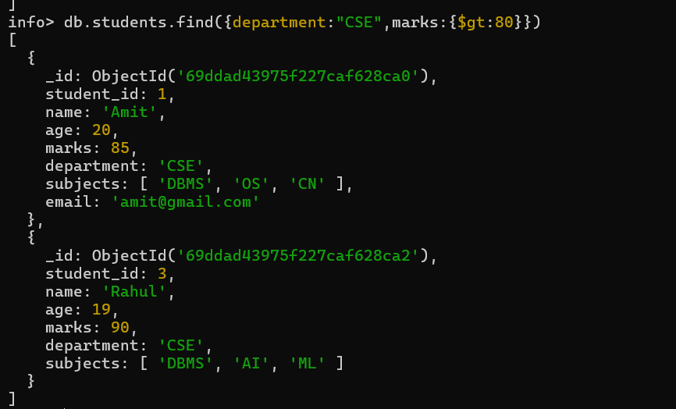
- Find students who are in CSE or have marks above 85.
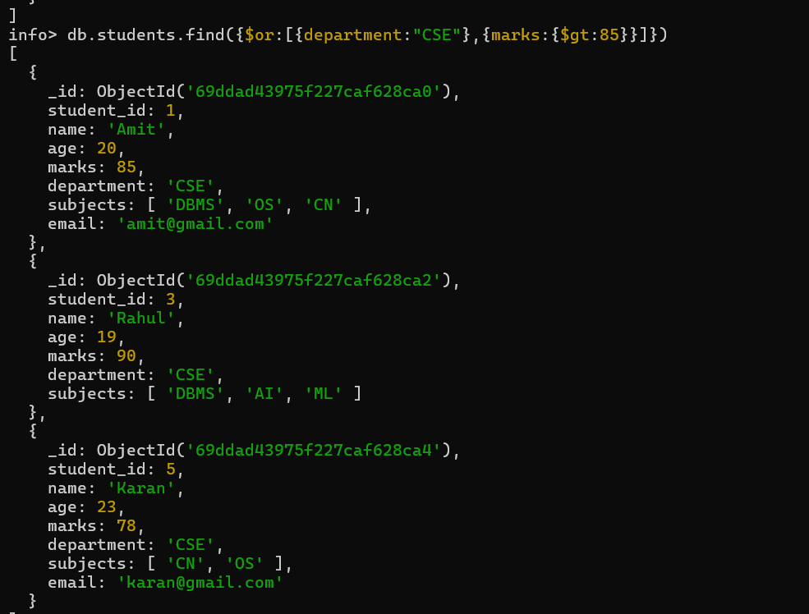

- Find students who are NOT in IT department.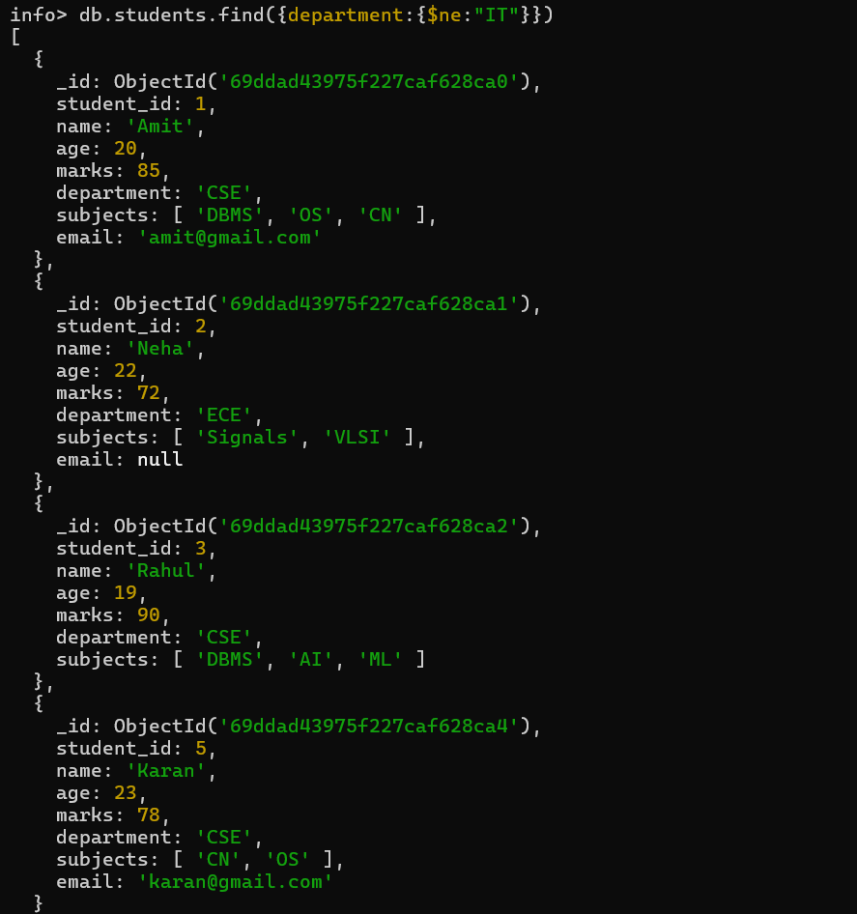
- Find students with marks not between 70 and 85.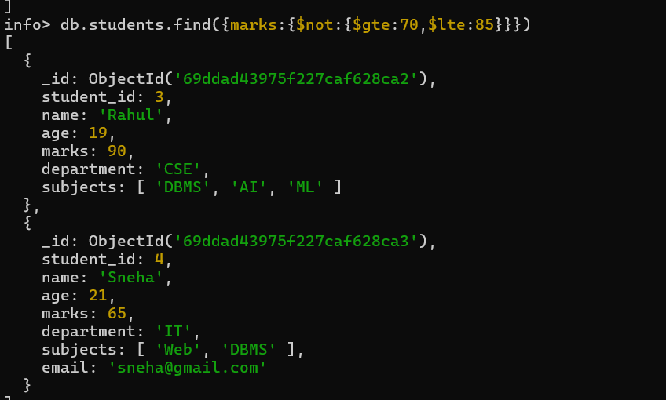
- Find students aged above 20 and not in ECE.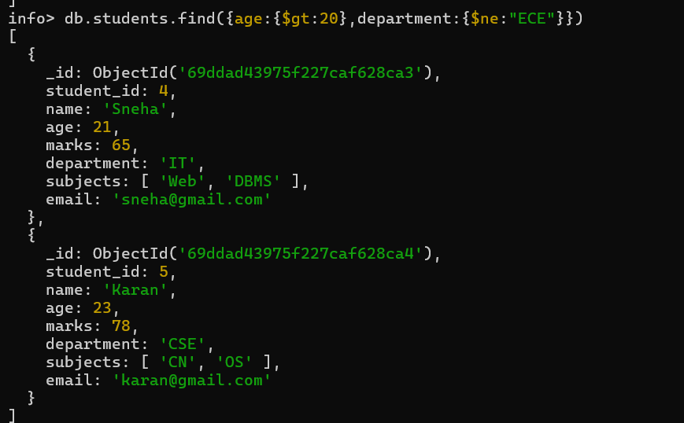
- Find students who are either IT students or have marks less than 70.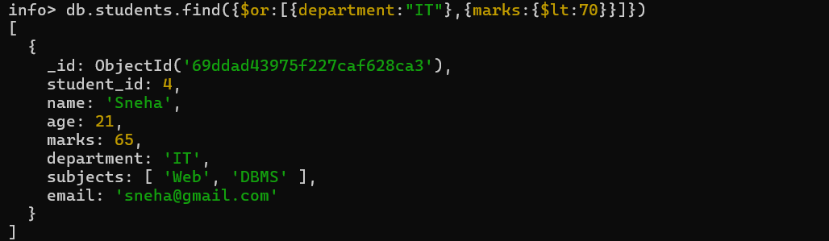
- Find students who are not CSE and not IT.
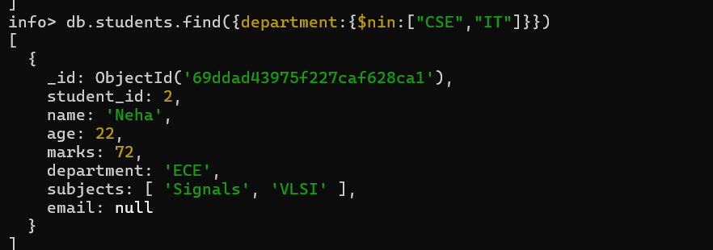
- Find students who have an email field.
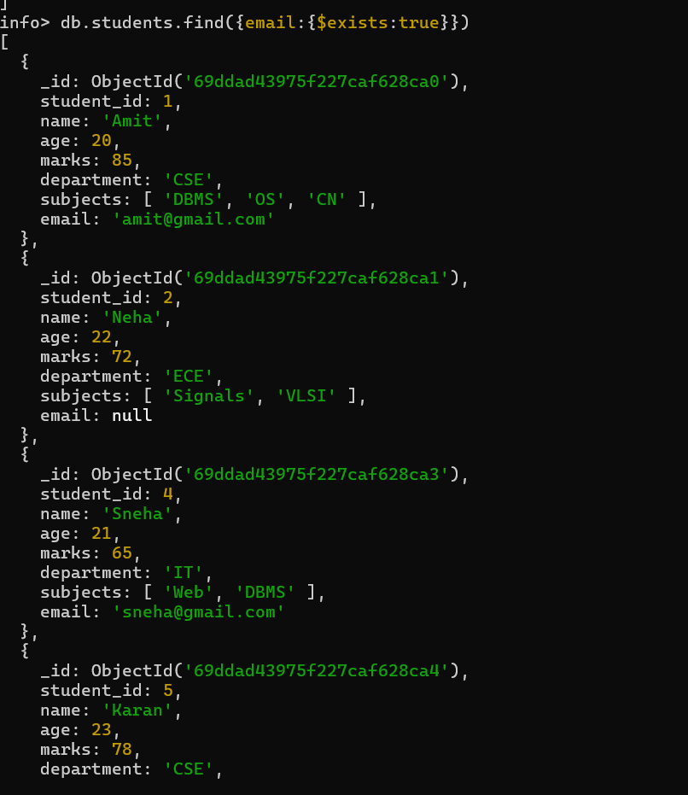
- Find students who do not have an email field.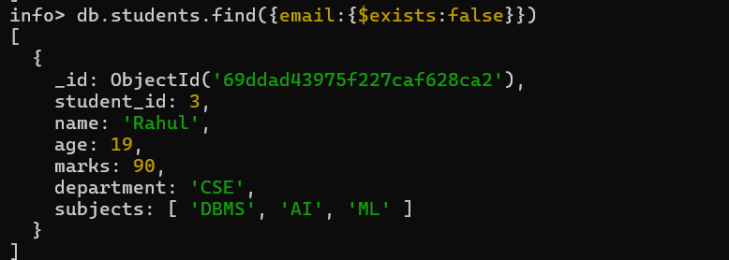
- Find students whose email value is null.
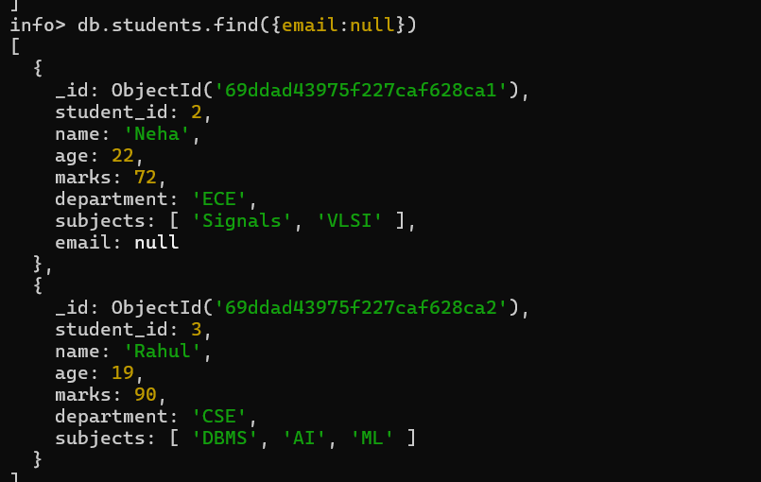
- Find students whose marks field is of type integer.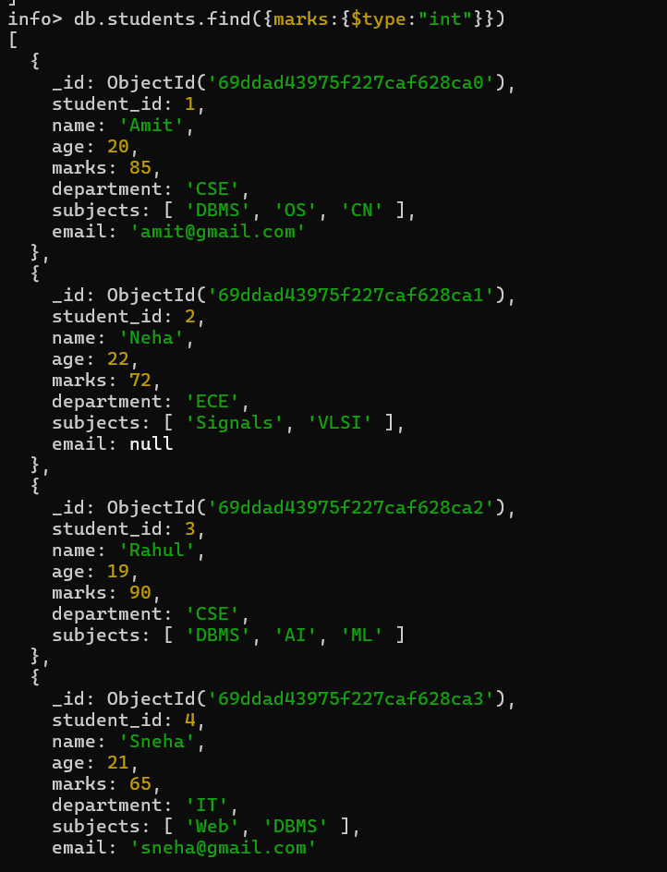
- Find students who have subjects’ field.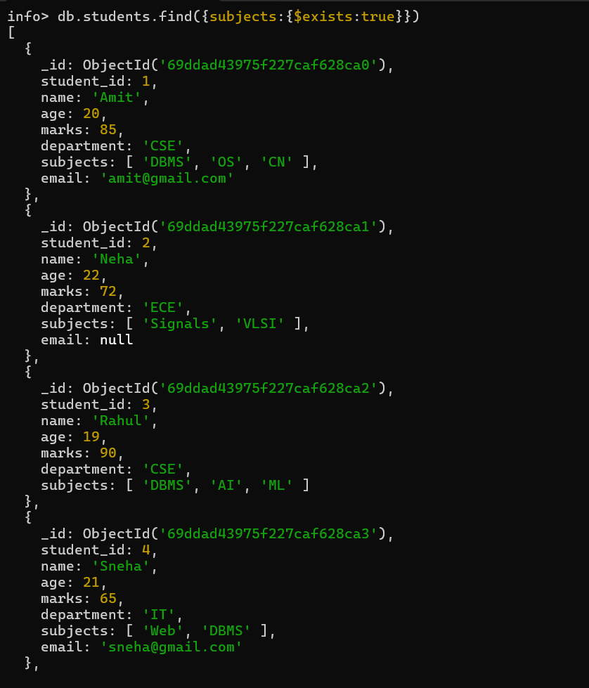
- Find students whose age field is missing.
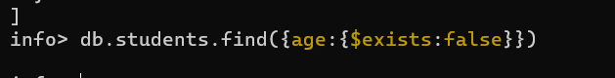
- Find students where marks modulo 5 equals 0.
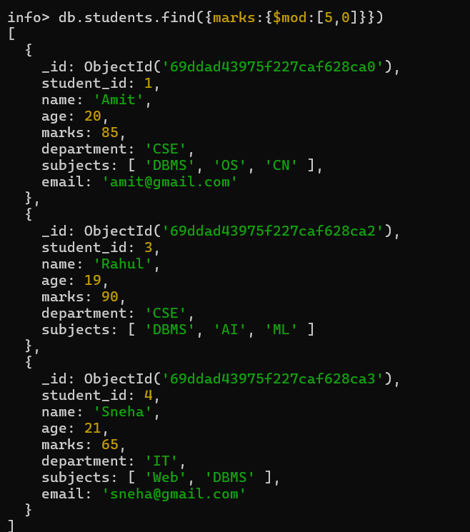
- Find students whose name starts with letter “A”.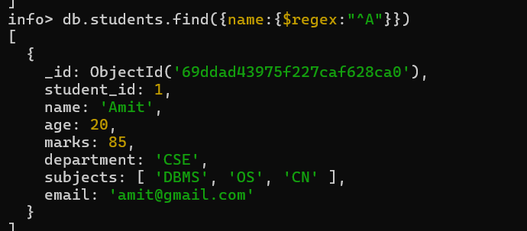
- Find students whose email ends with gmail.com.
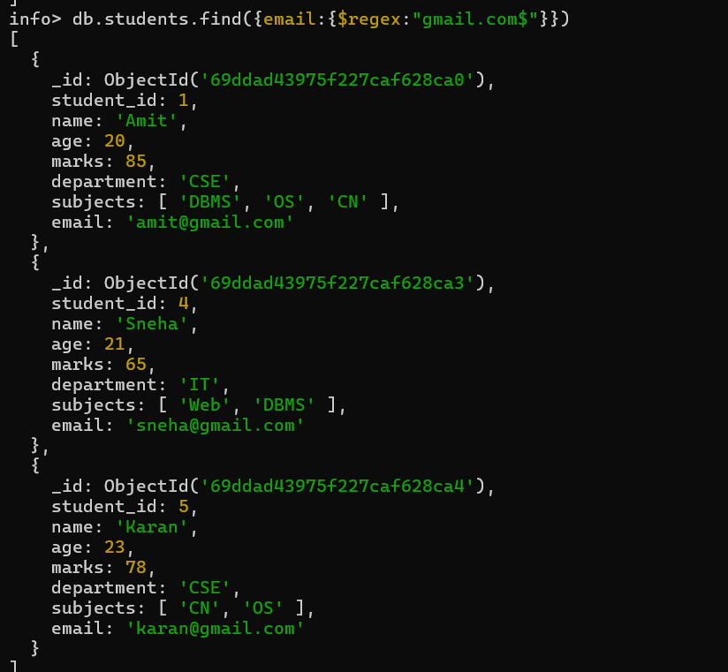

- Find students who have more than 2 subjects.
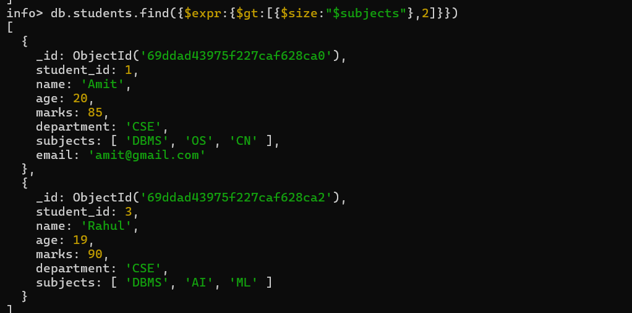

- Find students whose marks are greater than their age × 3.